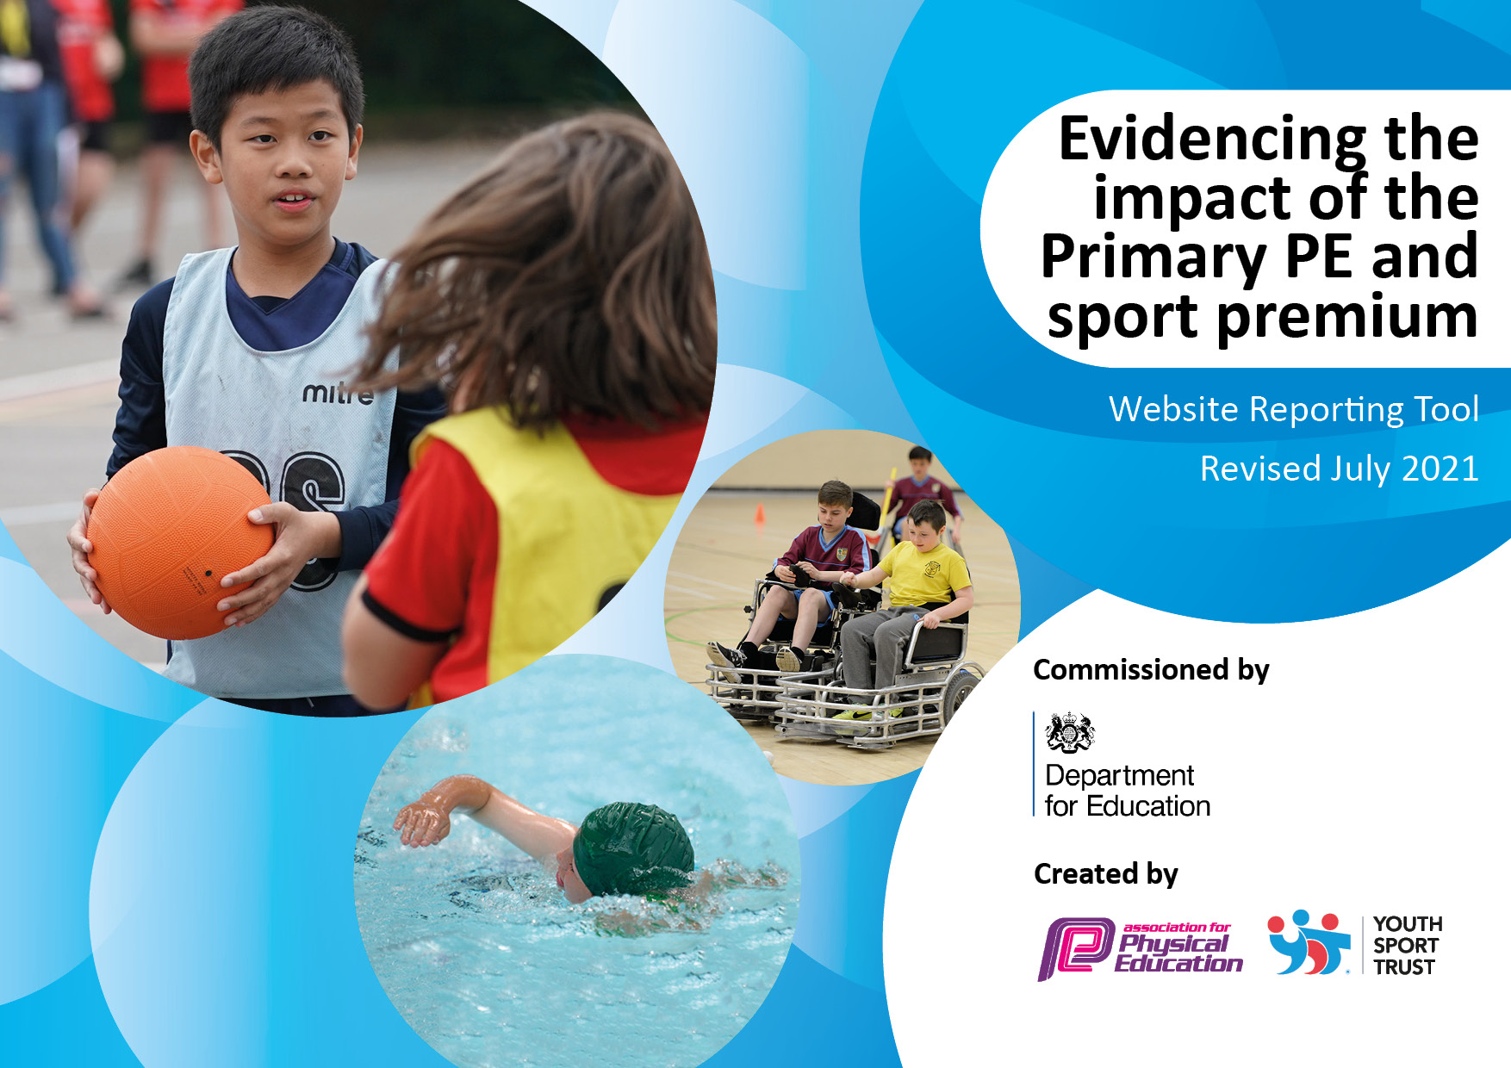
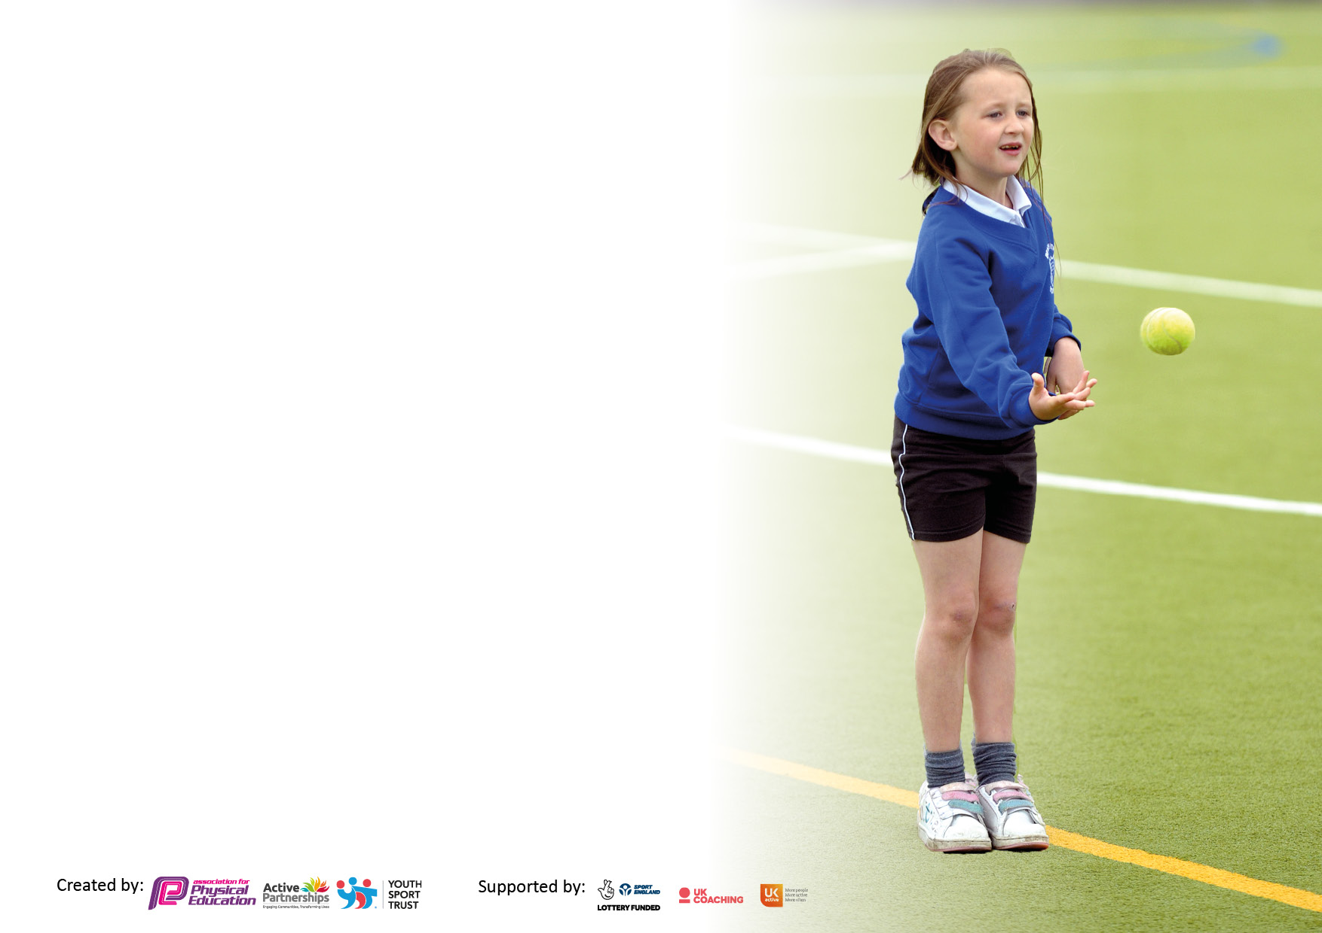

It is important that your grant is used effectively and based on school need. The Education Inspection Framework makes clear there will be a focus on ‘whether leaders and those responsible for governors all understand their respective roles and perform these in a way that enhances the effectiveness of the school’.

Under the Quality of Education Ofsted inspectors consider:
Intent - Curriculum design, coverage and appropriateness
Implementation - Curriculum delivery, Teaching (pedagogy) and Assessment
Impact - Attainment and progress

To assist schools with common transferable language this template has been developed to utilise the same three headings which should make your plans easily transferable between working documents.

Schools must use the funding to make additional and sustainable improvements to the quality of Physical Education, School Sport and Physical Activity (PESSPA) they offer. This means that you should use the Primary PE and sport premium to:

- Develop or add to the PESSPA activities that your school already offer
- Build capacity and capability within the school to ensure that improvements made now will benefit pupils joining the school in future years
- The Primary PE and sport premium should not be used to fund capital spend projects; the school’s budget should fund these.

Pleasevisitgov.ukfortherevisedDfEguidanceincludingthe5keyindicatorsacrosswhichschoolsshoulddemonstrate animprovement.Thisdocumentwillhelpyoutoreviewyourprovisionandtoreportyourspend.DfEencouragesschools to use this template as an effective way of meeting the reporting requirements of the Primary PE and sport premium.

We recommend you start by reflecting on the impact of current provision and reviewing the previous spend.

Schools are required to publish details of how they spend this funding, including any under-spend from 2019/2020, as well as on the impact it has on pupils’ PE and sport participation and attainment. All funding must be spent by 31st July 2022.

We recommend regularly updating the table and publishing it on your website throughout the year. This evidences your ongoing self-evaluation of how you are using the funding to secure maximum, sustainable impact. Final copy must be posted on your website by the end of the academic year and no later than the 31st July 2021. To see an example of how to complete the table please click HERE.
Created by: Supported by:

Details with regard to funding
Please complete the table below.

Total amount carried over from 2019/20 | £ 0
Total amount allocated for 2020/21 | £ 0
How much (if any) do you intend to carry over from this total fund into 2021/22? | £0
Total amount allocated for 2021/22 | £ 18,460
Total amount of funding for 2021/22. To be spent and reported on by 31st July 2022. | £18,460
Swimming Data
Please report on your Swimming Data below.

Meeting national curriculum requirements for swimming and water safety.

N.B. Complete this section to your best ability. For example you might have practised safe self-rescue techniques on dry land which you can then transfer to the pool when school swimming restarts.
Due to exceptional circumstances priority should be given to ensuring that pupils can perform safe self rescue even if they do not fully meet the first two requirements of the NC programme of study
What percentage of your current Year 6 cohort swim competently, confidently and proficiently over a distance of at least 25 metres?  N.B. Even though your pupils may swim in another year please report on their attainment on leaving primary school at the end of the summer term 2021.  Please see note above | 85%
What percentage of your current Year 6 cohort use a range of strokes effectively [for example, front crawl, backstroke and breaststroke]?  Please see note above | 90%
What percentage of your current Year 6 cohort perform safe self-rescue in different water-based situations? | 98%
Schools can choose to use the Primary PE and sport premium to provide additional provision for swimming but this must be for activity over and above the national curriculum requirements. Have you used it in this way? | No

Action Plan and Budget Tracking
Capture your intended annual spend against the 5 key indicators. Clarify the success criteria and evidence of impact that you intend to measure to evaluate for pupils today and for the future.

Academic Year: 2021/22 | Total fund allocated:£ £18500 | Date Updated: July 2022
Key indicator 1: The engagement of all pupils in regular physical activity – Chief Medical Officers guidelines recommend that primary school pupils undertake at least 30 minutes of physical activity a day in school |  |  |  | Percentage of total allocation:
 |  |  |  | %
Intent | Implementation |  | Impact
Your school focus should be clear what you want the pupils to know and be able to do and about  what they need to learn and to  consolidate through practice: | Make sure your actions to achieve are linked to your intentions: | Funding allocated: | Evidence of impact: what do pupils now know and what can they now do? What has changed?: | Sustainability and suggested next steps:
Support children to understand how being active can lead a balanced lifestyle through lunchtime clubs. | Playground leaders and selected KS2 children to attend Playground leadership training. | £800 | The children can now confidently engage and support and encourage other children on the playground to become active at break and lunchtimes. | Next steps: carry out the training for other pupils and teaching assistants.
Improving the quality of PE offered so enjoyment is enhanced. | All pupils to access 2 hours high quality PE every week. Developed through sports coaches, through staff INSET (half a day) with Trust schools, and through improved resources. | £11,000 | The children have had high quality teaching from both sports coaches and staff. Staff have become more confident with teaching PE because of the staff inset. Therefore the children’s self esteem has improved and they have developed a new positive attitude to trying new sports. This positivity from the pupils have led the children to be successful at fixtures. | Due to the success of the impact, this will continue.
Daily exercise | 5 minutes of daily exercise for each class. Ensure teachers are happy with resources and activities. | £100 | Pupils became fitter and found a new enjoyment to exercise. They also had an opportunity to show teamwork with their class mates. | The sustainability isn’t realistic with timetabling, however, next steps on incorporating it into break and lunchtimes for next academic year.
Sport recognition awards throughout the year | Having a sporting hero assembly once a term. In Summer the year term have a Sports Personality of the Year award assembly. | £100 | Pupils were motivated to achieve the sport recognition award due to the sporting opportunities at the school throughout the year. | This will continue next year.
Intra-class competitions to be held every half term. As well as ensuring that the active continued to be supported, the challenge was to target those inactive, by introducing children to a new sport or a wider range of sports that ALL children could feel confident in participating in. | Children from each class will participate in intra-class competitions in the sport they have learnt in their PE lessons that half term. | £500 | Sporty and non-sporty pupils competed in competitive sport. Which led to motivate more pupils to signup to sport after school clubs. | Continue to focus on identifying Young Sports Leaders.  Sustainability of intra-class competition happening once a half term isn’t sustainable, next year to make it once a term.
Key indicator 2: The profile of PESSPA being raised across the school as a tool for whole school improvement |  |  |  | Percentage of total allocation:
 |  |  |  | %
Intent | Implementation |  | Impact
Your school focus should be clear what you want the pupils to know and be able to do and about  what they need to learn and to  consolidate through practice: | Make sure your actions to achieve are linked to your intentions: | Funding allocated: | Evidence of impact: what do pupils now know and what can they now do? What has changed?: | Sustainability and suggested next steps:
To ensure all children are proficient in the fundamentals of sport | Within the children’s 2 hours of quality PE lessons each week, the children were set 3 targets each lesson and they can choose what target they will meet. | See above | Pupils have improved their attitudes to learning, with improved focus and motivation. | Continue this into next academic year.
Increase parent participation at the school | Parents were invited to participate and attend competitions throughout the year. | £0 | Parent participation encouraged children to participate in sports clubs outside of school. | This will be continued next academic year.
Leaders must improve the opportunities for pupils to develop their understanding of other cultures and faiths to be prepared for life in modern Britain | British Sports stars who are from different cultures and faiths to be identified and displayed during start of a new PE topic. This will be part of the assembly timetable. | £0 | Children were able to recognise and discuss with their peers athletes that aren’t in the mainstream media. | This wasn’t consistently maintained. For next year, this will be implemented in the starter sessions of PE when the children are choosing their targets for the lesson and in assemblies.

Key indicator 3: Increased confidence, knowledge and skills of all staff in teaching PE and sport |  |  |  | Percentage of total allocation:
 |  |  |  | %
Intent | Implementation |  | Impact
Your school focus should be clear | Make sure your actions to | Funding | Evidence of impact: what do | Sustainability and suggested
what you want the pupils to know | achieve are linked to your | allocated: | pupils now know and what | next steps:
and be able to do and about | intentions: |  | can they now do? What has
what they need to learn and to |  |  | changed?:
consolidate through practice:
Provide lesson plans for the teachers who teach P.E. so they are confident when teaching. Team teach to raise standards and positive attitudes | PE lead worked with the staff in advance to ensure they were happy with the planning and the teaching of PE. | £500 | Staff were aware of resources and plans to use to implement ‘good’ PE lessons. This supported their confidence. | This will continue next year to support staff.
PE Lead to be confident in modelling Outstanding lessons are being taught | PE lead to attend CPD during the academic year. | £400 | Outstanding PE lessons were taught to whole school following the lesson plans provided from PE lead before she went on maternity. | Due to PE lead being on Maternity leave it wasn’t able to be implemented, however this will happen next academic year.
Staff training to be implemented to all staff so everyone knows how the PE curriculum is delivered. | A half day inset with the cluster trust schools focused on striking and fielding, invasive games and strength and flexibility. | £200 | All staff were aware of the implementation of PE across the school and it supported the confidence with delivering PE lessons. | This will be continued next year due to the success.
Sign 2 more members of staff up for the minibus training so they are able to transport children to and from fixtures on school minibus. | PE lead contacted Admin staff to find a date for the course and to be able to find staff cover | £2000 | Children were able to participate in more competitive fixtures across the year due to the availability of staff. | This won’t need to be continued next year as a sufficient amount of staff are now qualified to drive the minibus.
Key indicator 4: Broader experience of a range of sports and activities offered to all pupils |  |  |  | Percentage of total allocation:
Intent | Implementation |  | Impact
Your school focus should be clear | Make sure your actions to | Funding | Evidence of impact: what do | Sustainability and suggested
what you want the pupils to know | achieve are linked to your | allocated: | pupils now know and what | next steps:
and be able to do and about | intentions: | £ | can they now do? What has
what they need to learn and to |  |  | changed?:
consolidate through practice:
To continue our afterschool club provision and provide a wide range of sports and activities for all pupils. These sessions let the children practice the skills they have been learning in lessons and to put them in match play. These sessions are taught by qualified, specialised and motivated sport coaches/teachers. | A minimum of 1 sport after-school club were offered to pupils each day to all children. These clubs were run by sports coaches and teachers. | £2000 | Clubs were full and there was a culture of ‘opting in’ and trying new sports. | Continue the afterschool club provision.
Provide golf and cricket sessions for specific year groups in the summer term by specialised sports coaches. | We continued are popular JOLF day, introducing children to a new sport or a sport they haven’t played much of. | £700 | Children actively joined a golf club outside of school after these sessions. It inspired them to participate in new sport after school clubs. | The local cricket club will come and teach a session of cricket to all year groups to gain interest in joining an outdoor local club.
Children have access to our Wrap Around Care club | To give children the opportunity to be active for longer periods of the day and to socialise with peers. | £2000 | Children were given the opportunity to be active for longer periods of the day and to provide a healthy balanced diet. | To continue the running of our Wrap Around Care service, invite children to join our breakfast/after- school sessions.
Pupil Premium children to join holiday camps held at our school. | Children who wouldn’t usually be active during the school holidays, able to be. | £1000 | Children were given the opportunity to be active and socialise with peers when they wouldn’t have been able to. | Next steps: to continue to offer places to PP chn to join the active holiday camps during school holidays.
Children to have opportunities to access Mindful activities to encourage positive mental and physical health (targeted pupils from each year group) | Subscription to SmilingMind to raise the profile of Physical and Mental wellbeing. Created by leading yoga and mindful experts and child psychologists. Class teachers timetabled it so it happened daily. | £0 - Free | SmilingMind strengthened their self-control, lowered their anxiety and stress. It increased their positive moods which led to better decision making and their understanding of Emotional Regulation.  Increases self-esteem. | Next steps: to continue the subscription
Year 6 children who take a keen interest and participate in sport across the school to join local secondary school after school clubs in Summer term. | To liaise with PE lead at local secondary school so a small group of children can join in with a sport club. |  | The sustainability of staffing was the reason for this not to happen. | Next steps: PE lead will work with local secondary school to make it happen.

Key indicator 5: Increased participation in competitive sport |  |  |  | Percentage of total allocation:
 |  |  |  | %
Intent | Implementation |  | Impact
Your school focus should be clear | Make sure your actions to | Funding | Evidence of impact: what do | Sustainability and suggested
what you want the pupils to know | achieve are linked to your | allocated: | pupils now know and what | next steps:
and be able to do and about | intentions: |  | can they now do? What has
what they need to learn and to |  |  | changed?:
consolidate through practice:
Increase participation in sports fixtures across all years | PE lead worked with SGO.  PE lead worked with local secondary school and sports provider company to organise training which would then lead to a competition with cluster schools in our area. (all years) | Free | Children experienced competitive fixtures, understood the importance of committing to training and influenced participation in out of school clubs.  Their determination and participation led the children to become the Championship champions. | To continue this into next year.
Increase girls and PP participation in intra- school competitions | We monitored the amount of girls and PP signing up for after-school sports clubs.  We also monitored who was being chosen to represent the school during competitions to ensure variety. | £300 | Improved self-esteem  Demonstrated a positive attitude to trying new sports.  Opportunities to excel at new events.  More girls participated in schools. | To continue this next year
Line markings in the field for football and athletics. | It allowed competitive sport with appropriate marking for the field. | £400 | A range of competitive sport was played on the field. | This provision will continue next year.

Signed off by
Head Teacher: | C.James
Date: | 30/07/22
Subject Leader: | E.Boyd
Date: | 30/07/22
Governor: | E.Boyd (Teacher Governor)
Date: | 30/07/22

